Add line win event

1. Select slotcontroller, select pay line, check showevent, click ”+”

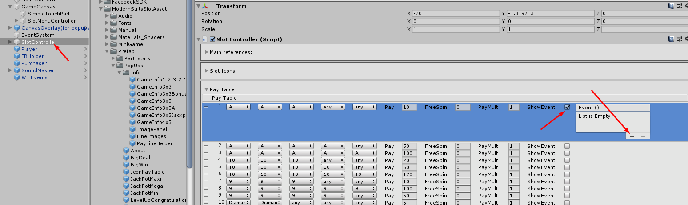

1. Drag WinEvents object in to empty field

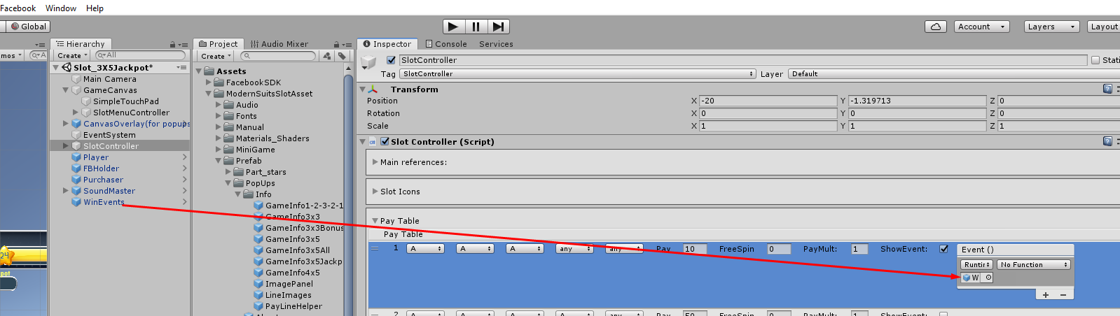

1. Add your EventHandler method to SlotEvents.cs

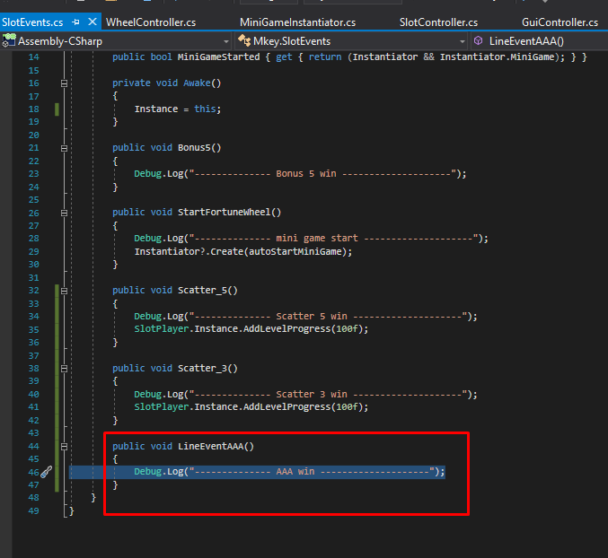

1. Select your handler

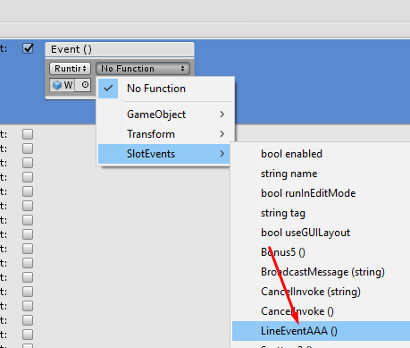

1. Uncheck ShowEvent (this does not affect the triggering event)

